The Three Financial Statements: How They Link and How to Explain It
Meta description: WSG founder Stephen Turban explains how the three financial statements link, walks $10 of depreciation and ten more scenarios, and shows how to say it.

"How do the three financial statements link together?" If you've typed that into a search bar this semester, you're asking the right question, because every bank asks the interview version of it. Goldman Sachs asks it. A middle market bank in Charlotte asks it. A two-partner boutique that hires one Summer Analyst a year asks it, usually in the first five minutes. The wording is almost always the same: "Depreciation goes up by $10. Walk me through the three statements." Interviewers love it because it takes ninety seconds, needs no notes, and shows whether you understand how profit, cash and the balance sheet move together or whether you memorized a paragraph.

I'm Stephen Turban, founder of WallStreetGuide. I went to Harvard and through McKinsey's on-cycle recruiting before I started WSG, where I now spend my weeks advising undergrads through the banking pipeline. I've listened to the $10 answer go wrong in the same three spots for years: the tax, the sign on cash, and the balance sheet check at the end.

This guide fixes all three. It walks each statement in plain words, the six links between them, the order to walk them in an interview, the $10 of depreciation answer line by line at a 25 percent tax rate, ten more scenarios worked the same way, and a small company whose statements tie to the dollar. Then the follow-ups, where each line sits in a 10-K, and the mistakes that lose the question.

How do the three financial statements link together?
Net income is the bridge. It's the last line of the income statement, the first line of the cash flow statement, and it flows into retained earnings on the balance sheet. The cash flow statement then takes every expense that didn't use cash (depreciation, for one) and every cash move the income statement never sees (capital spending, borrowing, dividends) and lands on ending cash, which is the cash line on the balance sheet. The three financial statements link through net income at the top of the cash flow statement, through balance sheet changes that the cash flow statement turns into cash, and through ending cash landing back on the balance sheet. When all of those links are right, assets equal liabilities plus equity.

What is the $10 of depreciation question?
It's the standard way an interviewer tests those links: "Depreciation increases by $10. Walk me through the three statements." At a 25 percent tax rate the answer runs like this. Pre-tax income falls by 10, taxes fall by 2.5, net income falls by 7.5. On the cash flow statement net income starts 7.5 lower, but the 10 of depreciation is added back because no cash left the company, so cash is up 2.5. On the balance sheet cash is up 2.5 and net PP&E is down 10, so total assets are down 7.5, and retained earnings are down 7.5 on the other side, so it balances. The $10 of depreciation question tests whether you know that an expense with no cash behind it still changes cash, through the tax it saves. Section 4 walks every line.

1. Each of the three financial statements answers one question over one kind of time
Before the links, the pieces. Each statement is built to answer a different question, and the reason the three exist at all is a choice accountants made long ago about when to count a sale.

The income statement answers "did the company make money this period," and it counts profit when it's earned, not when the cash shows up. It covers a stretch of time, a quarter or a year. Revenue sits at the top. Then come the costs: cost of goods sold (what it cost to make or buy the thing that was sold), operating expenses like selling, general and administrative costs and research, and depreciation and amortization, which may have their own line or sit inside the lines above. What's left after those is operating income, also called EBIT, earnings before interest and taxes. Subtract interest on the company's debt and you get pre-tax income. Subtract taxes and you get net income, the bottom line. The lines an interviewer cares about are revenue, cost of goods sold, operating income, interest, taxes and net income.

The rule that shapes everything is accrual accounting. A sale counts as revenue when the product ships or the service is delivered, even if the customer pays sixty days later. A cost counts when the company uses the thing, even if the bill is paid next month. Depreciation is the clearest case: a company buys a $100 machine and pays cash today, but the income statement charges $10 a year for ten years instead, because the machine produces for ten years. The income statement is a picture of economic activity, not a bank statement. That gap between activity and cash is the reason the other two statements exist.

In a 10-K the income statement sits in Item 8, usually titled "Consolidated Statements of Operations" or "Consolidated Statements of Income."

The balance sheet answers "what does the company own and owe right now," and it balances because every dollar of assets was paid for by either a lender or an owner. It's a snapshot on one date, the last day of the quarter or year, not a stretch of time. The left side (or the top) lists assets: cash, accounts receivable (money customers owe the company), inventory, property, plant and equipment (PP&E), and goodwill and intangibles from past acquisitions. The right side lists where the money to buy those assets came from. Liabilities are other people's money: accounts payable (money owed to suppliers), accrued expenses (costs recorded but not yet paid, like wages earned this week and paid next week), deferred revenue (cash customers paid before getting the product) and debt. Shareholders' equity is the owners' money: the stock they paid for, plus retained earnings, which is every dollar of profit the company has ever kept rather than paid out as a dividend.

Assets equal liabilities plus equity on every balance sheet ever published, and not because someone forces the total. Every asset was funded by someone. A $40 million cash balance came from customers' payments that the company kept (retained earnings), from a bank (debt), or from investors (stock). There's no fourth source. The equation is just that fact written as arithmetic.

The cash flow statement answers "where did the cash actually go," and it exists to undo the accrual accounting of the income statement. It starts with net income and then corrects it, line by line, until it reaches the real change in the bank balance. Three sections. Cash from operations takes net income, adds back expenses that didn't use cash (depreciation, amortization, and stock-based compensation, which is paying employees in shares instead of cash), and then adjusts for changes in working capital, meaning the short-term balance sheet items like receivables, inventory and payables that soak up or release cash. Cash from investing shows capital spending on long-lived assets and any acquisitions or asset sales. Cash from financing shows debt raised or repaid, stock issued or bought back, and dividends paid. The three sections add to the net change in cash. Beginning cash plus that change is ending cash.

One piece of history that surprises students: the cash flow statement is the youngest of the three. Before 1988, US companies published a "statement of changes in financial position," a table of where funds came from and where they went that most companies built around working capital rather than the cash balance itself. The Financial Accounting Standards Board issued Statement No. 95 in November 1987, requiring a statement of cash flows in its place for fiscal years ending after July 15, 1988. So the statement you'll walk through in a first round is about 38 years old, while the balance sheet goes back five centuries. More on that in section 2.

2. The six links are the whole machine, and the three financial statements only work as a set
Every interview question about the statements, from the $10 of depreciation to "what happens if the company buys back stock," is a question about one or more of six connections. Learn the six and you can answer a scenario you've never seen. I'll put a number on each one here, and in section 6 you'll see the same numbers assembled into a full set of statements for a fictional bicycle maker, Lantern Bikes Co.

Link 1: net income goes to the top of the cash flow statement and into retained earnings. Net income is the last line of the income statement. The cash flow statement starts from it because net income is the best available first guess at cash, and the rest of the statement corrects that guess. On the balance sheet, retained earnings at the end of the year equal retained earnings at the start, plus net income, minus dividends paid. Lantern Bikes earns 45 in Year 2 and pays a 12 dividend: the cash flow statement starts at 45, and retained earnings rise by 33.

Link 2: depreciation and amortization cut profit, come back on the cash flow statement, and shrink PP&E. Depreciation spreads the cost of a physical asset over the years it's used. Amortization does the same for intangible assets like patents or acquired customer lists. Together they're D&A. On the income statement they're an expense. On the cash flow statement they're added back to net income, because the cash left the company when the asset was bought, not this year. On the balance sheet, net PP&E (the original cost minus all the depreciation charged so far) falls by the same amount. Lantern Bikes charges 30 of D&A: operating income is 30 lower, the cash flow statement adds 30 back, and net PP&E falls by 30.

Link 3: capital expenditures use cash in the investing section and raise PP&E, and they never touch the income statement in the year they're spent. Capital expenditure, or capex, is money spent on assets that last more than a year: factories, trucks, servers, store build-outs. Spending it shows up as a negative number in cash from investing and as an increase in PP&E on the balance sheet. The income statement doesn't see it until depreciation starts charging it, a slice at a time. Lantern Bikes spends 40 on new equipment: cash from investing shows negative 40, net PP&E rises by 40, and the income statement is unchanged. Put links 2 and 3 together and you have the whole PP&E roll-forward: ending net PP&E equals beginning net PP&E plus capex minus D&A. For Lantern Bikes that's 300 plus 40 minus 30, which is 310.

Link 4: changes in working capital translate balance sheet movements into cash, and the sign rule is the one students get backwards. Working capital is the short-term stuff the business runs on. Receivables are sales the company has booked but hasn't collected. Inventory is product the company has paid for but hasn't sold. Payables and accrued expenses are costs the company has recorded but hasn't paid. When an operating asset like receivables goes up, the income statement counted revenue the bank account never received, so the cash flow statement subtracts the increase. When an operating liability like payables goes up, the company used supplier money instead of its own, so the cash flow statement adds the increase. The rule in four words: asset up, cash down. Liability up, cash up. Lantern Bikes' receivables rise by 10 and inventory by 5, while payables rise by 6 and accrued expenses by 2. The operating section shows negative 10, negative 5, positive 6 and positive 2, a net 7 of cash absorbed.

Link 5: debt raised or repaid runs through the financing section and lands on the balance sheet, while the interest on it runs through the income statement. Borrow 100 and cash from financing shows positive 100 while debt on the balance sheet rises by 100. Repay it and both reverse. The principal never touches the income statement. The interest does: it's an expense, computed off the debt balance that sits on the balance sheet. Lantern Bikes repays 20 of its 200 of debt in Year 2: financing shows negative 20, debt ends at 180, and the income statement carries 10 of interest, which is 5 percent on the 200 it started the year with.

Link 6: the last line of the cash flow statement is the first line of the balance sheet. Add operating, investing and financing cash flows and you get the net change in cash for the year. Add that to the cash the company started with and you have ending cash, and ending cash is the cash line on the balance sheet. Lantern Bikes starts Year 2 with 40, its three sections net to negative 4, and it ends with 36. The balance sheet shows 36. There's no separate calculation; it's the same number in two places.

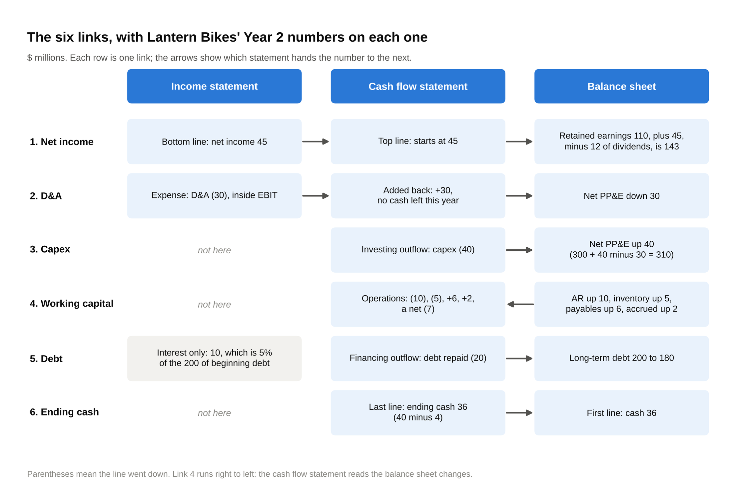
Six rows, six links: net income and D&A start on the income statement, capex, debt and ending cash run from the cash flow statement to the balance sheet, and working capital runs the other way.

Those six are the full set. Here's why they guarantee the balance sheet balances, in plain words, because interviewers ask that too.

Every transaction touches at least two things, and the two sides move by the same amount. Spend cash on a machine and cash falls while PP&E rises: two assets, total unchanged. Borrow money and cash rises while debt rises: an asset and a liability, both sides up together. Earn a profit and cash (eventually) rises while retained earnings rise: an asset and equity, both sides up. Pay a dividend and cash falls while retained earnings fall. Record depreciation and PP&E falls while retained earnings fall through lower net income. There is no transaction that moves only one side of the balance sheet. A balance sheet balances because every transaction moves two things by the same amount, so if yours doesn't balance, you missed a link or flipped a sign, never anything else.

That double-sided idea is older than almost anything else in finance. In 1494 a Franciscan friar named Luca Pacioli published a mathematics textbook in Venice, the Summa de arithmetica, geometria, proportioni et proportionalita, written for the merchant schools of northern Italy. One section described the bookkeeping method Venetian merchants already used, in which every entry had a matching entry on the other side. Pacioli didn't invent it; he wrote it down well enough that it spread, and the system in that chapter is the one that makes your balance sheet balance today. Three years later he moved to Milan, where he taught mathematics to Leonardo da Vinci and lived in the same household. Leonardo drew the illustrations for Pacioli's next book. The person who codified double-entry bookkeeping and the person who painted the Last Supper were roommates.

3. Walk the three financial statements in the order income statement, cash flow statement, balance sheet
The order isn't a style choice. It's the only order in which each statement hands the next one the number it needs.

Start with the income statement because it produces net income, and net income is the first line of the cash flow statement. Go to the cash flow statement second because it produces ending cash, and ending cash is a line on the balance sheet. Finish on the balance sheet because now you know cash, you know PP&E, you know retained earnings, and you can check that assets equal liabilities plus equity. Walking the statements in the order income statement, cash flow statement, balance sheet means every number you need has already been computed by the time you need it, and the balance check at the end proves you got it right.

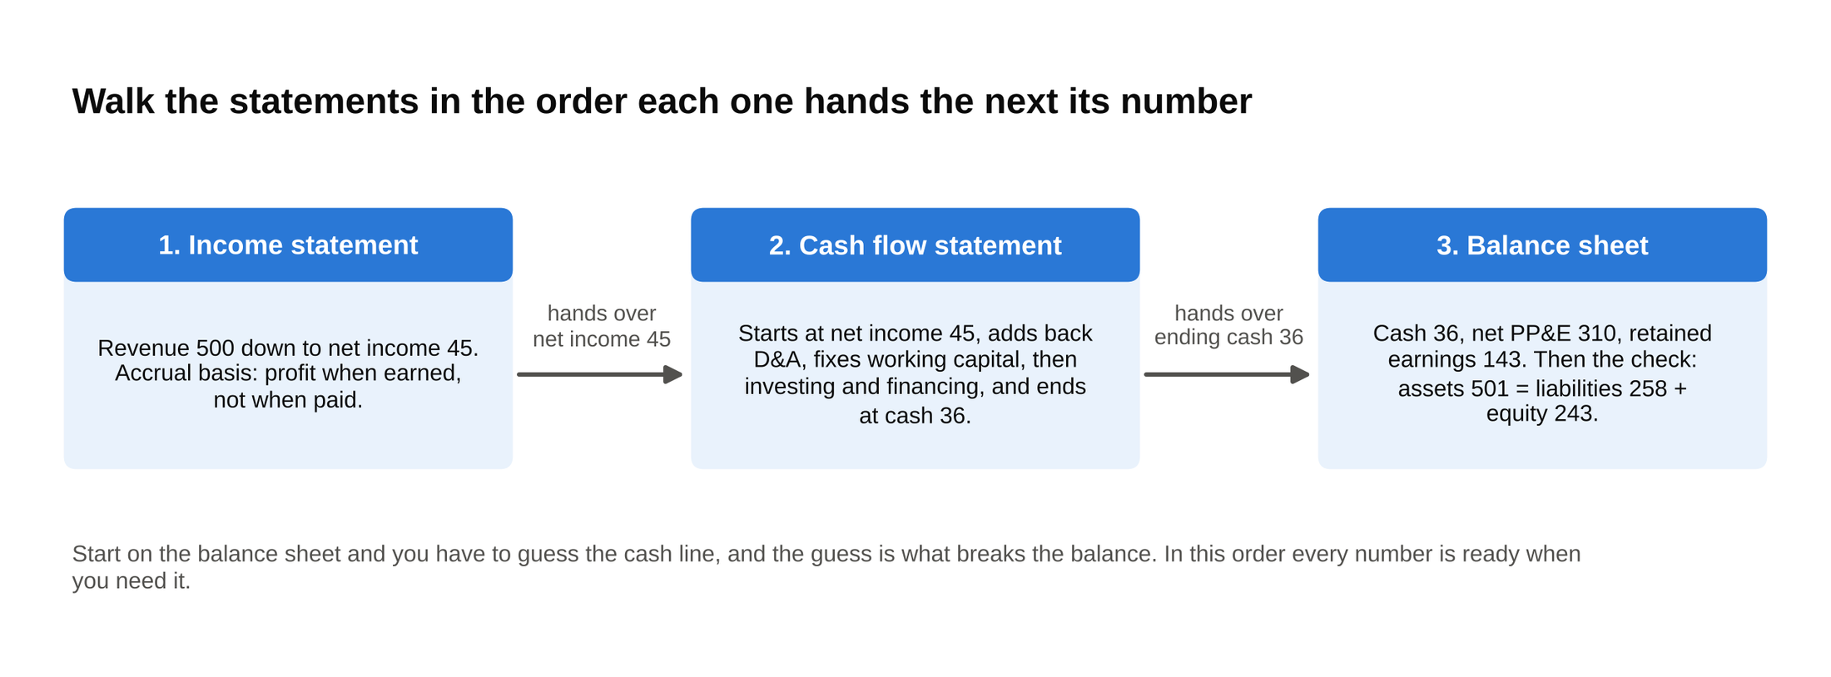
The order is forced by the hand-offs: the income statement produces the 45 the cash flow statement starts from, and the cash flow statement produces the 36 the balance sheet needs.

Students who start on the balance sheet get stuck on the cash line, because they haven't worked out the cash effect yet. They guess, and the guess is usually that cash moves by the whole expense. Then the balance sheet doesn't balance and they don't know why. Starting on the balance sheet forces you to guess the cash line, and that guess is what breaks the balance. Start on the income statement and it can't happen.

Here's the 30-second version of "walk me through the three statements," for a phone screen or a coffee chat that turns into one:

"The income statement shows revenue and expenses over a period and ends in net income. Net income is the first line of the cash flow statement, which adds back non-cash expenses like depreciation, adjusts for changes in working capital, then shows investing and financing activity, and ends in the change in cash. That ending cash lands on the balance sheet, which shows assets, liabilities and equity at a point in time. Net income also flows into retained earnings on the balance sheet, so the three tie together through net income and through cash."

And the two-minute version, for a first round where the interviewer wants the links named:

"The income statement covers a period and goes from revenue down through cost of goods sold, operating expenses and depreciation to operating income, then interest and taxes, to net income. It's on an accrual basis, so it records revenue when earned and costs when incurred, not when cash moves.
The cash flow statement fixes that. It starts with net income, adds back non-cash items like D&A and stock-based compensation, then adjusts for working capital: an increase in an operating asset like receivables or inventory is a use of cash, an increase in an operating liability like payables is a source. That gets you to cash from operations. Investing shows capex and acquisitions. Financing shows debt raised or repaid, buybacks and dividends. The three sections sum to the net change in cash.
The balance sheet is a snapshot. Assets equal liabilities plus equity. It connects to the other two in three places: net income minus dividends goes into retained earnings, D&A and capex change PP&E, and the ending cash from the cash flow statement is the cash line. Working capital changes and debt changes on the cash flow statement are just the year-over-year changes in those balance sheet lines. If every link is right, the balance sheet balances."

Both versions name the links. Neither one defines what a balance sheet is for someone who already knows. Say the long one out loud twice before your first round; it should take about 100 seconds without rushing.

4. Walk me through $10 of depreciation, line by line
Now the question itself. Depreciation, at first use: when a company buys an asset that lasts years, it doesn't expense the whole cost in the year of purchase. It charges a slice each year, and that slice is depreciation. The cash went out when the asset was bought. The depreciation charge is accounting catching up, which is the reason it's called a non-cash expense, and the reason the answer below has a twist.

Assume a 25 percent tax rate, and say so before you start. I ran every number below in a script before writing it down; the 40 percent column shows what older guides print, for reasons I'll get to.

The $10 depreciation walk, 25 percent tax rate (the 40 percent column is what older guides show)

Line | 25% tax rate | 40% tax rate
Income statement: depreciation expense | 10 | 10
Income statement: pre-tax income | (10) | (10)
Income statement: taxes | (2.5) | (4)
Income statement: net income | (7.5) | (6)
Cash flow statement: net income (top line) | (7.5) | (6)
Cash flow statement: add back depreciation | 10 | 10
Cash flow statement: cash from operations | 2.5 | 4
Cash flow statement: net change in cash | 2.5 | 4
Balance sheet: cash | 2.5 | 4
Balance sheet: net PP&E | (10) | (10)
Balance sheet: total assets | (7.5) | (6)
Balance sheet: retained earnings | (7.5) | (6)
Balance sheet: total liabilities and equity | (7.5) | (6)
Balance check (assets minus liabilities and equity) | 0 | 0

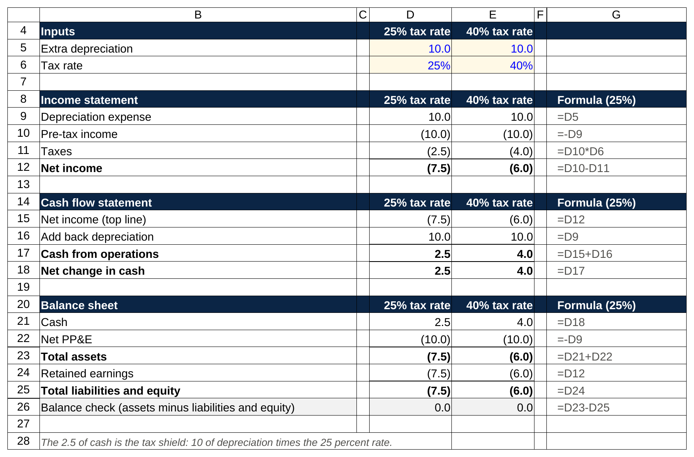
The same walk in a sheet: taxes are pre-tax income times the rate, the add-back is the depreciation line, and cash lands at 2.5, which is 10 times 25 percent.

Parentheses mean the line went down. Here's the walk in words, the way you'd say it.

Income statement. Depreciation is an expense, so operating income falls by 10 and pre-tax income falls by 10. The company owes tax on 10 less of profit, so at 25 percent its tax bill falls by 2.5. Net income falls by 10 minus 2.5, which is 7.5.

Cash flow statement. Start at the top with net income, which is 7.5 lower. Now add back the 10 of depreciation, because it's an expense that didn't use any cash this year. Negative 7.5 plus 10 is positive 2.5, so cash from operations is up 2.5. Nothing changes in investing or financing, so the net change in cash is up 2.5.

Balance sheet. On the asset side, cash is up 2.5 (from the cash flow statement) and net PP&E is down 10 (the depreciation reduced the book value of the equipment). Assets are down 7.5 in total. On the other side, net income was down 7.5, so retained earnings are down 7.5, and liabilities and equity are down 7.5. Both sides fell by 7.5. It balances.

Then the sentence that shows you understood it rather than recited it: depreciation is a non-cash expense, and cash still goes up by 2.5, because depreciation is tax deductible and the tax it saves is real cash. The 2.5 is 10 times the 25 percent tax rate. Bankers call it the tax shield, and it's the whole reason the question exists. If you say "depreciation is non-cash, so cash doesn't change," you've failed the question in one sentence.

Now the tax rate. The free question guides most students download first use 40 percent, so net income falls by 6 and cash rises by 4. That number dates from when the US federal corporate rate was 35 percent and a few points of state tax took the combined rate to about 40. The Tax Cuts and Jobs Act cut the federal rate to a flat 21 percent starting January 1, 2018 [VERIFY: federal statutory corporate rate still 21 percent at publish], so 21 plus state lands around 25 for most US companies today. Either tax rate is acceptable in an interview, and the only wrong choice is not saying which one you're using. A silent assumption is what gets marked wrong, because the interviewer can't check your arithmetic. One other sentence to have ready: depreciation can sit in its own line, inside cost of goods sold, or inside operating expenses, depending on the company, and it reduces pre-tax income no matter where it's printed.

Three places this goes wrong, in the order I hear them. First, the tax: students drop net income by the full 10. Second, the sign on cash: students say cash falls because "there was an expense," forgetting the add-back. Third, the balance sheet: students remember PP&E is down 10 and cash is up 2.5 but forget that retained earnings moved, so their assets fall 7.5 and their liabilities and equity don't move, and they stop talking. Retained earnings move every time net income moves. That's link 1.

5. Ten more scenarios, each worked the same way
The $10 of depreciation is the opener. The follow-ups below are what separates a prepared candidate from one who memorized a single answer. Every one of them is the same drill: income statement, cash flow statement, balance sheet, check. Tax rate is 25 percent throughout, and the arithmetic in every table ties to the depreciation walk. Some of these take four sentences. Some take a paragraph. That's how it goes in the room too.

Inventory goes up by $10, paid in cash

Nothing on the income statement. Inventory becomes an expense only when it's sold, through cost of goods sold; until then it's an asset sitting in a warehouse. On the cash flow statement, inventory is an operating asset, and an asset going up is a use of cash: cash from operations falls by 10. On the balance sheet, inventory is up 10 and cash is down 10, both assets, so total assets don't move and nothing on the other side moves.

Line | Change
Income statement | no change
Cash flow statement: change in inventory (asset up, cash out) | (10)
Cash flow statement: cash from operations | (10)
Cash flow statement: net change in cash | (10)
Balance sheet: cash | (10)
Balance sheet: inventory | 10
Balance sheet: total assets | 0
Balance sheet: total liabilities and equity | 0
Balance check | 0

Buying inventory never touches the income statement, and the most common wrong answer to this question is to put it there.

Inventory goes up by $10, bought on credit

Same purchase, but the supplier hasn't been paid. Still nothing on the income statement. On the cash flow statement there are now two working capital lines: inventory up 10 (an asset up, cash out) and accounts payable up 10 (a liability up, cash in). They cancel, so cash from operations is unchanged and cash doesn't move. On the balance sheet, inventory is up 10 on the asset side and accounts payable is up 10 on the liability side. Both sides rose by 10.

Line | Change
Income statement | no change
Cash flow statement: change in inventory (asset up, cash out) | (10)
Cash flow statement: change in accounts payable (liability up, cash in) | 10
Cash flow statement: cash from operations | 0
Cash flow statement: net change in cash | 0
Balance sheet: inventory | 10
Balance sheet: total assets | 10
Balance sheet: accounts payable | 10
Balance sheet: total liabilities and equity | 10
Balance check | 0

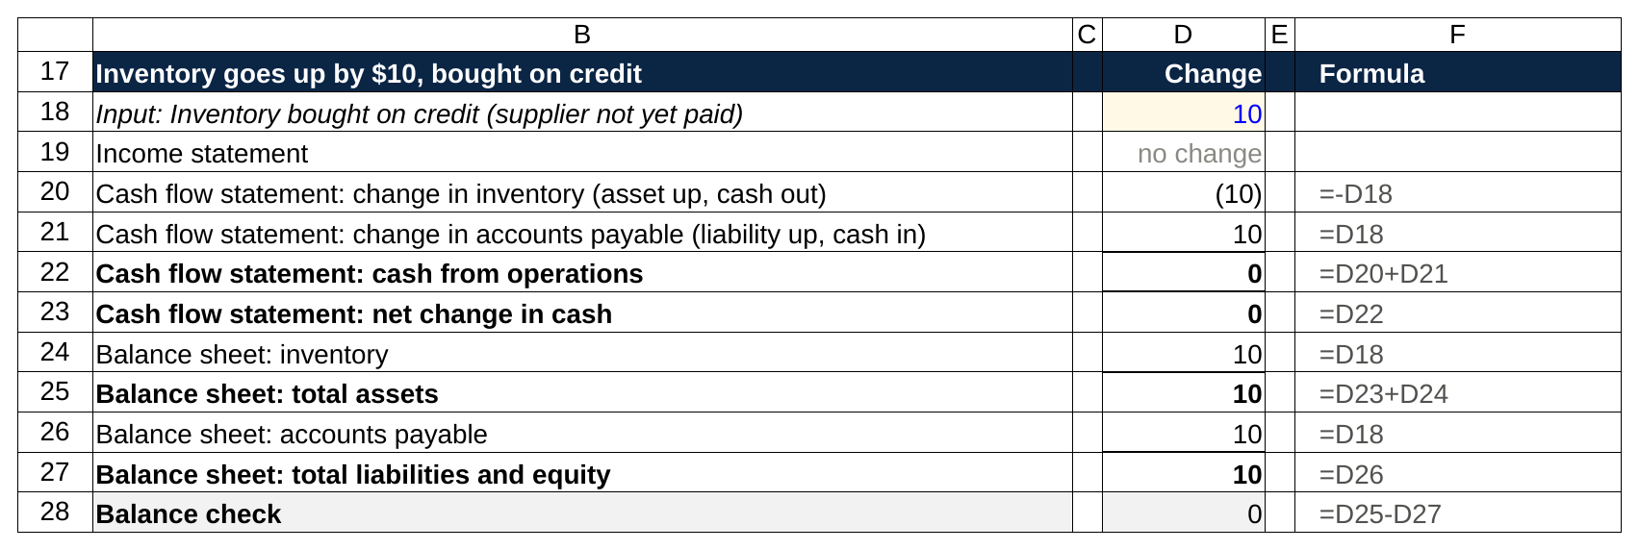
Two working capital lines that cancel: inventory up is cash out, payables up is cash in, so cash from operations is 0 and both sides of the balance sheet rise by 10.

The point of the pair: the first version shrinks cash, the second doesn't, and the income statement is identical in both. Working capital questions are all about who has paid whom.

$100 of capex, paid in cash

Nothing on the income statement this year; the expense arrives later as depreciation. On the cash flow statement, the 100 is an outflow in cash from investing, so the net change in cash is negative 100. On the balance sheet, cash is down 100 and net PP&E is up 100. Total assets are unchanged. Capex is the clearest example of a cash outflow with no income statement effect, which is the mirror image of depreciation, an income statement expense with no cash outflow.

Line | Change
Income statement | no change
Cash flow statement: cash from operations | 0
Cash flow statement: capital expenditures (investing) | (100)
Cash flow statement: net change in cash | (100)
Balance sheet: cash | (100)
Balance sheet: net PP&E | 100
Balance sheet: total assets | 0
Balance sheet: total liabilities and equity | 0
Balance check | 0

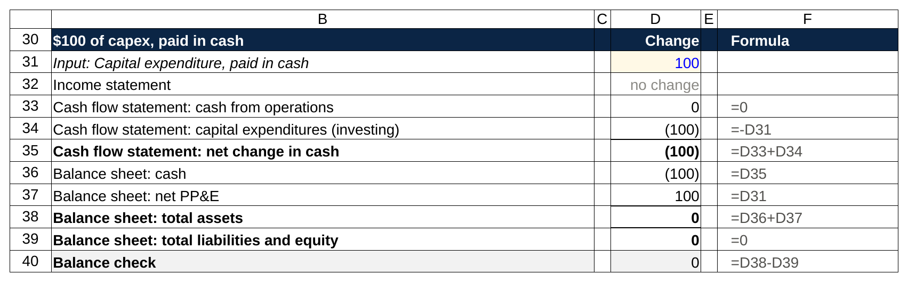
Capex never visits the income statement in the year it is spent: the 100 leaves through investing and reappears as PP&E, so total assets do not move.

The usual follow-up is "now go out a year," which combines this with the depreciation walk: if the 100 depreciates over ten years, next year's income statement carries 10 of depreciation and the table from section 4 applies.

Raise $100 of debt

No income statement effect at the moment of borrowing. Cash from financing shows positive 100. Cash is up 100 on the balance sheet, debt is up 100 on the other side.

Line | Change
Income statement | no change
Cash flow statement: cash from operations | 0
Cash flow statement: debt issued (financing) | 100
Cash flow statement: net change in cash | 100
Balance sheet: cash | 100
Balance sheet: total assets | 100
Balance sheet: long-term debt | 100
Balance sheet: total liabilities and equity | 100
Balance check | 0

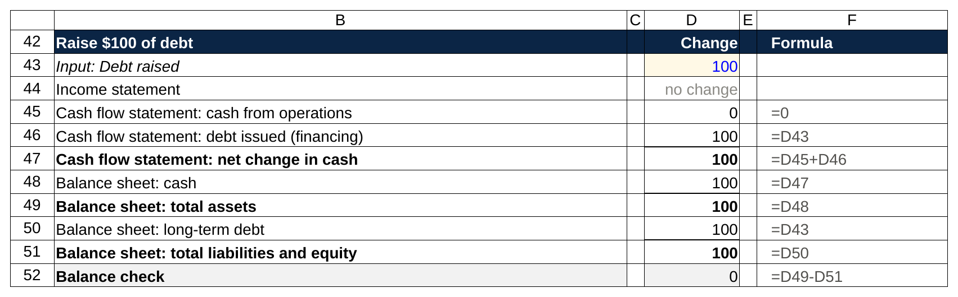
Borrowing is a financing line and a balance sheet line only: cash and debt both rise by 100, and the interest shows up on next year's income statement.

Interviewers extend this one with an interest rate. At 5 percent, next year's income statement carries 5 of interest expense, net income falls by 3.75 after tax, and cash falls by 3.75, since interest, unlike depreciation, is paid in cash. The debt itself sits on the balance sheet unchanged until it's repaid.

Buy back $50 of stock

No income statement effect. Cash from financing shows negative 50. On the balance sheet, cash is down 50. On the equity side, the repurchased shares go into a line called treasury stock, which is a negative number inside shareholders' equity, so equity falls by 50. Assets down 50, liabilities and equity down 50.

Line | Change
Income statement | no change
Cash flow statement: cash from operations | 0
Cash flow statement: share repurchases (financing) | (50)
Cash flow statement: net change in cash | (50)
Balance sheet: cash | (50)
Balance sheet: total assets | (50)
Balance sheet: treasury stock (reduces equity) | (50)
Balance sheet: total liabilities and equity | (50)
Balance check | 0

A buyback has a second-order income statement effect that a sharp interviewer may ask about: the company now has less cash earning interest, so interest income falls a little next year, and fewer shares, so earnings per share rises. The buyback itself, in the year it happens, is a financing event and a balance sheet event only.

$20 of deferred revenue collected

A customer pays 20 up front for a service the company hasn't delivered yet. No revenue yet, so no income statement effect. On the cash flow statement, deferred revenue is an operating liability, and a liability going up is a source of cash: cash from operations is up 20. On the balance sheet, cash is up 20 and deferred revenue is up 20.

Line | Change
Income statement | no change
Cash flow statement: change in deferred revenue (liability up, cash in) | 20
Cash flow statement: cash from operations | 20
Cash flow statement: net change in cash | 20
Balance sheet: cash | 20
Balance sheet: total assets | 20
Balance sheet: deferred revenue | 20
Balance sheet: total liabilities and equity | 20
Balance check | 0

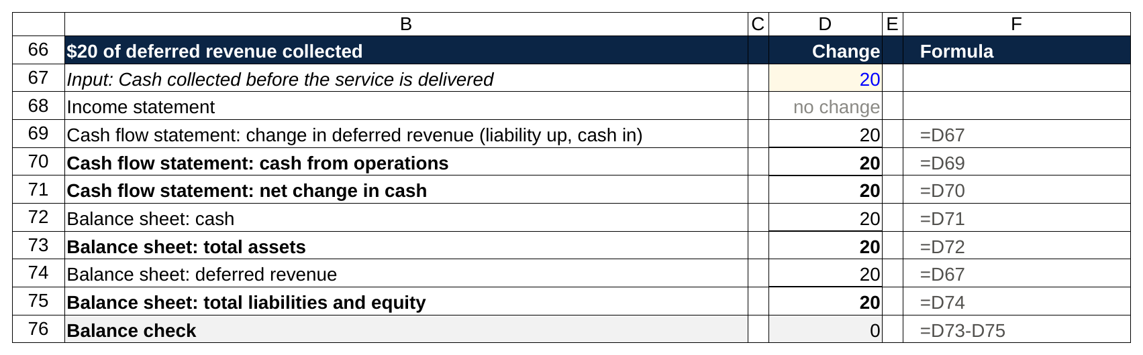
A liability going up is a source of cash: the 20 arrives in operations before any revenue is booked, and it sits in deferred revenue until the work is done.

Deferred revenue is the one liability a company is happy to see grow, because it's cash already in the bank for work still to come. As the service is delivered, the 20 moves out of deferred revenue and onto the income statement as revenue, with no further cash effect, which is why software companies with annual up-front billing can show cash from operations well above net income.

A $50 write-down of PP&E

A write-down (or impairment) is the company admitting an asset is worth less than its book value, usually because a plant closed or a product failed. Treat it as tax deductible for the walk, and say that you're doing so; in practice the tax effect is often deferred, and a good interviewer will accept the simpler version if you flag it.

Income statement: a 50 impairment charge, so pre-tax income falls by 50, taxes fall by 12.5, net income falls by 37.5. Cash flow statement: net income is 37.5 lower, but the write-down is a non-cash charge, so add 50 back; cash from operations is up 12.5. Balance sheet: cash is up 12.5, net PP&E is down 50, so assets are down 37.5. Retained earnings are down 37.5. Balanced.

Line | Change
Income statement: write-down expense | 50
Income statement: pre-tax income | (50)
Income statement: taxes | (12.5)
Income statement: net income | (37.5)
Cash flow statement: net income | (37.5)
Cash flow statement: add back write-down (non-cash) | 50
Cash flow statement: cash from operations | 12.5
Cash flow statement: net change in cash | 12.5
Balance sheet: cash | 12.5
Balance sheet: net PP&E | (50)
Balance sheet: total assets | (37.5)
Balance sheet: retained earnings | (37.5)
Balance sheet: total liabilities and equity | (37.5)
Balance check | 0

Notice the shape: a write-down is depreciation in one lump. Same three moves, bigger number. Once you see that, every "non-cash charge" question (goodwill impairment, a bad-debt provision) is the same walk with a different asset. Stock-based compensation is the same on the income statement and the cash flow statement too; the only difference is that the balance sheet offset lands in equity, since the company paid in shares, rather than in an asset.

A $10 dividend

Short one. Dividends come out of retained earnings, not out of net income, so the income statement doesn't move. Cash from financing shows negative 10. Cash is down 10, retained earnings are down 10.

Line | Change
Income statement | no change
Cash flow statement: cash from operations | 0
Cash flow statement: dividends paid (financing) | (10)
Cash flow statement: net change in cash | (10)
Balance sheet: cash | (10)
Balance sheet: total assets | (10)
Balance sheet: retained earnings | (10)
Balance sheet: total liabilities and equity | (10)
Balance check | 0

Accrued expenses go up by $10

The company recognizes 10 of expense it hasn't paid yet, say wages for the last week of the year, paid in January. Income statement: operating expenses up 10, pre-tax income down 10, taxes down 2.5, net income down 7.5. Cash flow statement: net income is 7.5 lower, but accrued expenses are an operating liability and a liability going up is a source of cash, so add 10; cash from operations is up 2.5. Balance sheet: cash is up 2.5. On the other side, accrued expenses are up 10 and retained earnings are down 7.5, a net 2.5. Both sides up 2.5.

Line | Change
Income statement: operating expense | 10
Income statement: pre-tax income | (10)
Income statement: taxes | (2.5)
Income statement: net income | (7.5)
Cash flow statement: net income | (7.5)
Cash flow statement: change in accrued expenses (liability up, cash in) | 10
Cash flow statement: cash from operations | 2.5
Cash flow statement: net change in cash | 2.5
Balance sheet: cash | 2.5
Balance sheet: total assets | 2.5
Balance sheet: accrued expenses | 10
Balance sheet: retained earnings | (7.5)
Balance sheet: total liabilities and equity | 2.5
Balance check | 0

Look at the numbers next to the depreciation walk. Identical. Accruing an expense you haven't paid has exactly the same three-statement effect as depreciation, because in both cases the income statement records a cost that cash hasn't felt yet. When the wages are paid in January, accrued expenses fall by 10 and cash falls by 10, with no income statement effect, and the cycle closes.

Sell equipment with a $30 book value for $40

The longest of the ten, and the one that catches candidates who've only drilled the depreciation walk. The company sells a machine. Its book value (original cost minus accumulated depreciation) is 30. The buyer pays 40 in cash.

Income statement: the company records a gain on sale of 10, the difference between the price and the book value. Pre-tax income is up 10, taxes are up 2.5, net income is up 7.5.

Cash flow statement, and here's the trap. Net income is 7.5 higher at the top. But the 10 gain is not cash from operations; the cash came from selling an asset, which belongs in investing. So the gain is subtracted in the operating section to avoid counting it twice: cash from operations is 7.5 minus 10, which is negative 2.5. That negative 2.5 is just the tax paid on the gain. Then the full 40 of proceeds shows up in cash from investing. Net change in cash: negative 2.5 plus 40 is 37.5.

Balance sheet: cash is up 37.5 and net PP&E is down 30 (the machine is gone), so assets are up 7.5. Retained earnings are up 7.5 from net income. Balanced.

Line | Change
Income statement: gain on sale | 10
Income statement: pre-tax income | 10
Income statement: taxes | (2.5)
Income statement: net income | 7.5
Cash flow statement: net income | 7.5
Cash flow statement: subtract gain on sale (non-cash) | (10)
Cash flow statement: cash from operations | (2.5)
Cash flow statement: proceeds from sale of equipment (investing) | 40
Cash flow statement: net change in cash | 37.5
Balance sheet: cash | 37.5
Balance sheet: net PP&E | (30)
Balance sheet: total assets | 7.5
Balance sheet: retained earnings | 7.5
Balance sheet: total liabilities and equity | 7.5
Balance check | 0

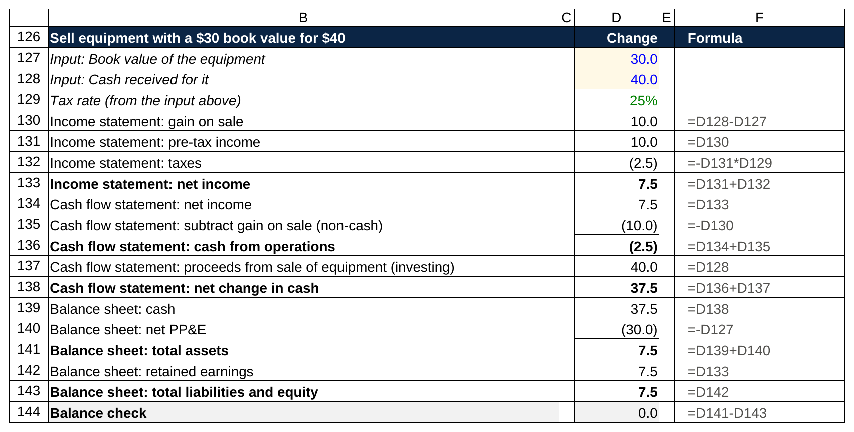
The trap in a sheet: net income is up 7.5, the 10 gain is backed out of operations, the full 40 of proceeds lands in investing, and cash ends up 37.5.

A gain on sale is subtracted from cash from operations for the same reason depreciation is added back: the income statement recorded something that isn't operating cash, and the cash flow statement has to put it where it belongs. Sell the same machine for 20 instead, and you'd record a 10 loss, add it back in operations, and show 20 of proceeds in investing. Same logic, opposite sign.

If you want more of these, the 50 accounting interview questions post goes wider, into goodwill, deferred taxes and the rest. The ten above are the ones I'd make sure you can do standing up.

6. Lantern Bikes: a mini set of three financial statements that tie
Scenarios test one link at a time. A real company moves all six at once, and the way to make the links permanent is to watch a full year happen. So here's Lantern Bikes Co., a fictional maker of commuter bicycles, going from the end of Year 1 to the end of Year 2. All figures are in $ millions and the tax rate is 25 percent. I built these tables in a script before writing, and it checks two things: the Year 2 balance sheet balances to zero, and ending cash on the cash flow statement equals cash on the balance sheet. The links are labeled in the right-hand column so you can trace each number to its partner.

Lantern Bikes Co., Year 2 income statement ($ millions)

Line | Year 2 | Where it goes
Revenue | 500
Cost of goods sold | (300)
Gross profit | 200
SG&A | (100)
Depreciation and amortization | (30) | Link 2: added back on the CFS, reduces PP&E
EBIT (operating profit) | 70
Interest expense (5% on beginning debt of 200) | (10) | Computed off the Year 1 debt balance
Pre-tax income | 60
Taxes (25%) | (15)
Net income | 45 | Link 1: top of the CFS and into retained earnings

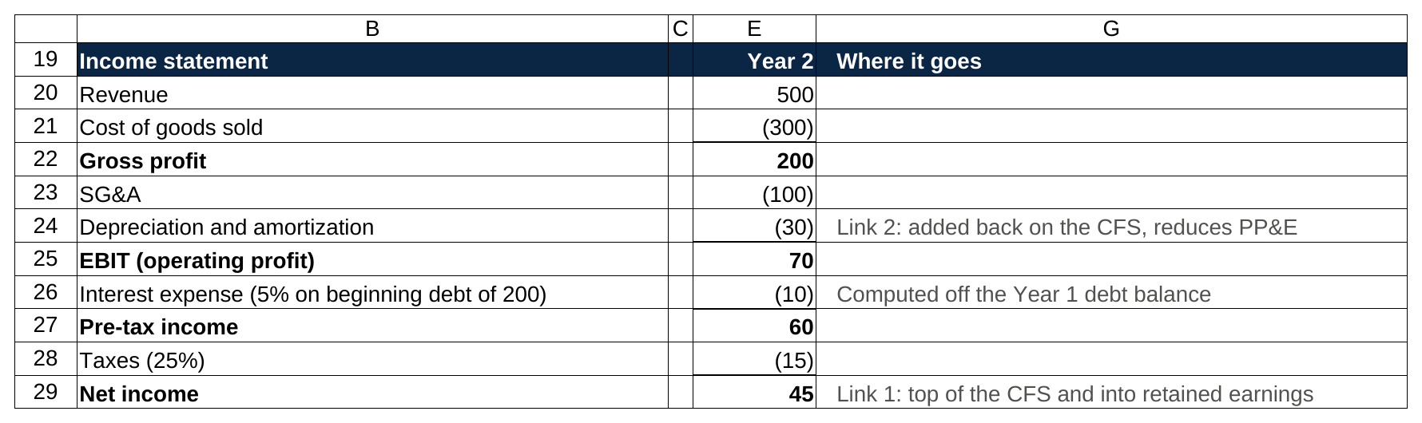
The income statement in the sheet: costs are negative, every subtotal is a sum, and interest is 5 percent of the 200 of debt on the Year 1 balance sheet.

Lantern Bikes Co., Year 2 cash flow statement ($ millions)

Line | Year 2 | Where it comes from or goes
Net income | 45 | Link 1: from the income statement
Plus: depreciation and amortization | 30 | Link 2: non-cash, added back
Less: increase in accounts receivable | (10) | Link 4: balance sheet AR 60 to 70
Less: increase in inventory | (5) | Link 4: inventory 80 to 85
Plus: increase in accounts payable | 6 | Link 4: payables 50 to 56
Plus: increase in accrued expenses | 2 | Link 4: accrued 20 to 22
Cash from operations | 68
Capital expenditures | (40) | Link 3: raises PP&E
Cash from investing | (40)
Debt repaid | (20) | Link 5: debt 200 to 180
Dividends paid | (12) | Reduces retained earnings
Cash from financing | (32)
Net change in cash | (4)
Beginning cash | 40 | Year 1 balance sheet
Ending cash | 36 | Link 6: becomes cash on the Year 2 balance sheet

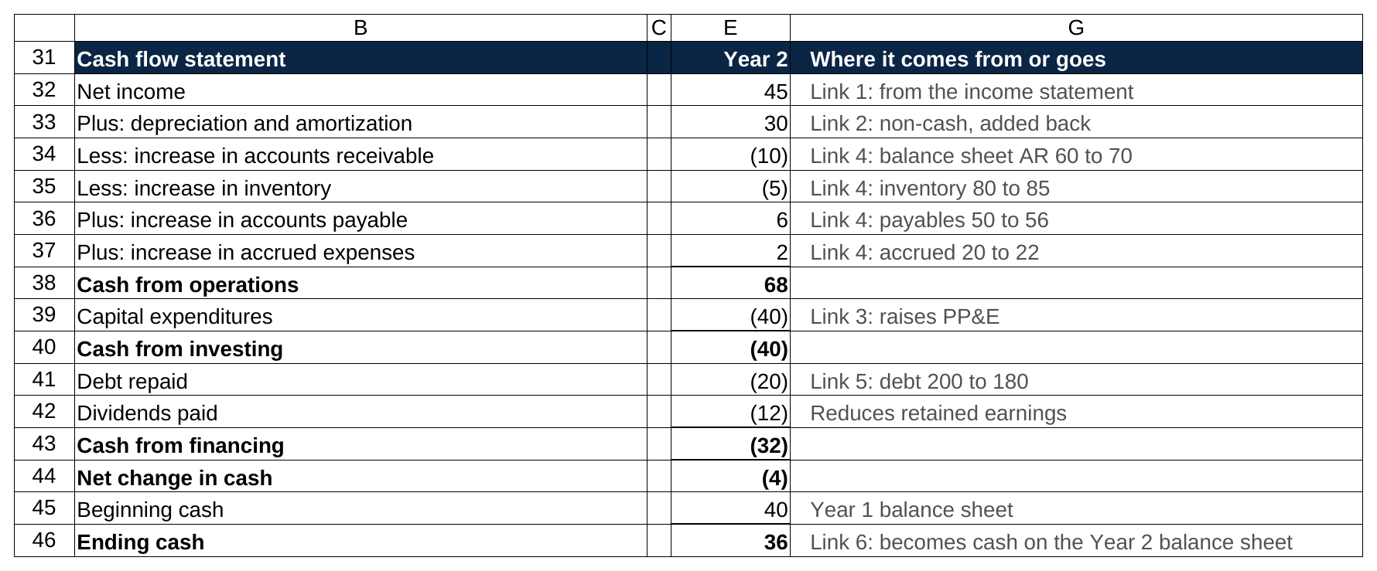
Net income 45 at the top, the four working capital lines netting to minus 7, operations at 68, then capex, the debt repayment and the dividend, and ending cash of 36.

Lantern Bikes Co., balance sheet, Year 1 to Year 2 ($ millions)

Line | Year 1 | Year 2 | Change | Why
Cash | 40 | 36 | (4) | Link 6: ending cash from the CFS
Accounts receivable | 60 | 70 | 10 | Link 4
Inventory | 80 | 85 | 5 | Link 4
Net PP&E | 300 | 310 | 10 | Links 2 and 3: plus capex 40, minus D&A 30
Total assets | 480 | 501 | 21
Accounts payable | 50 | 56 | 6 | Link 4
Accrued expenses | 20 | 22 | 2 | Link 4
Long-term debt | 200 | 180 | (20) | Link 5: repaid 20
Total liabilities | 270 | 258 | (12)
Common stock | 100 | 100 | 0 | No shares issued or bought back
Retained earnings | 110 | 143 | 33 | Link 1: plus net income 45, minus dividends 12
Total equity | 210 | 243 | 33
Total liabilities and equity | 480 | 501 | 21
Balance check (assets minus L+E) | 0 | 0 |  | Must be 0

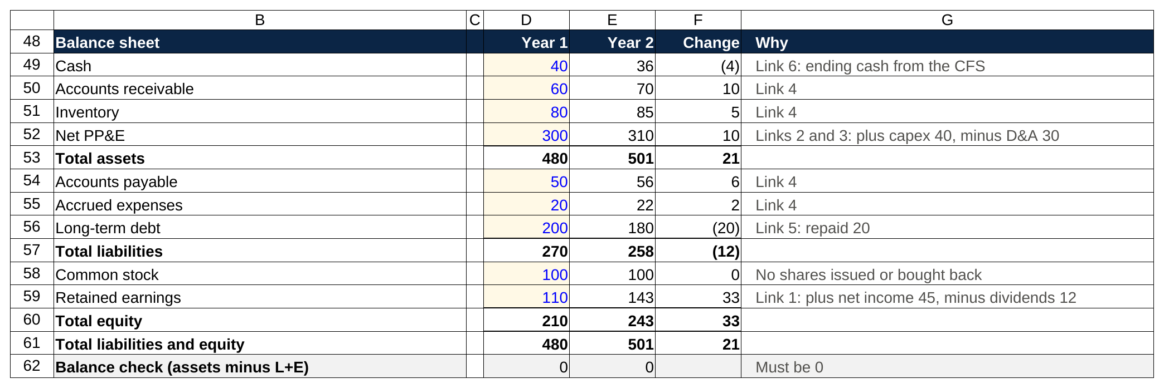
Year 1 is typed in blue, every Year 2 line is a formula off the Year 1 balance and a cash flow line, and the check row reads 0 in both years.

And the six links pulled out of those three tables into one place:

The six links in Lantern Bikes' Year 2

Link | Year 2 figure | Income statement | Cash flow statement | Balance sheet
1. Net income | 45 | Bottom line | Top line | Retained earnings up 45 before dividends
2. D&A | 30 | Expense | Added back | Net PP&E down 30
3. Capex | 40 | Not here | Investing outflow | Net PP&E up 40
4. Working capital | (7) | Not here | Net (7) in operations | AR up 10, inventory up 5, payables up 6, accrued up 2
5. Debt | (20) | Interest only | Financing outflow 20 | Debt 200 to 180
6. Ending cash | 36 | Not here | Last line | Cash line

What changed, and why. Lantern Bikes sold 500 of bicycles, kept 200 after the cost of making them, spent 100 running the company and charged 30 of depreciation on its factory and tooling, for 70 of operating profit. It paid 10 of interest on the 200 of debt it started the year with, and 15 of tax on the 60 that was left. Net income: 45. That 45 is the first number on the cash flow statement and the number that raises retained earnings, before the dividend.

Then the corrections. The 30 of depreciation never left the bank account this year, so it comes back. Customers owed Lantern Bikes 10 more at year end than at the start (receivables 60 to 70), so 10 of the revenue hasn't been collected yet and is subtracted. Inventory rose 5, so 5 of cash is sitting in unsold bicycles. On the other side, Lantern Bikes owed suppliers 6 more (payables 50 to 56) and employees 2 more (accrued 20 to 22), so 8 of its costs haven't been paid yet and that cash is still in the account. Net working capital absorbed 7. Cash from operations: 45 plus 30 minus 7, which is 68.

Then the spending the income statement never sees. 40 of capex on new equipment, which raises net PP&E by 40 while the 30 of depreciation lowers it, so net PP&E ends at 310. Then 20 of debt repaid and 12 of dividends paid, both out of cash and neither through the income statement. Add it up: 68 minus 40 minus 32 is negative 4. Lantern Bikes started with 40 of cash and ended with 36.

A company can earn 45 and end the year with less cash than it started with, and the cash flow statement is the only one of the three that shows you exactly why. Here's the bridge from profit to the change in cash, one step at a time:

Why Lantern Bikes' cash fell by 4 in a year it earned 45

Step | Amount | Running total
Net income | 45 | 45
Add back D&A (non-cash) | 30 | 75
Working capital build (AR 10 and inventory 5 out, payables 6 and accrued 2 in) | (7) | 68
Capex | (40) | 28
Debt repaid | (20) | 8
Dividends | (12) | (4)

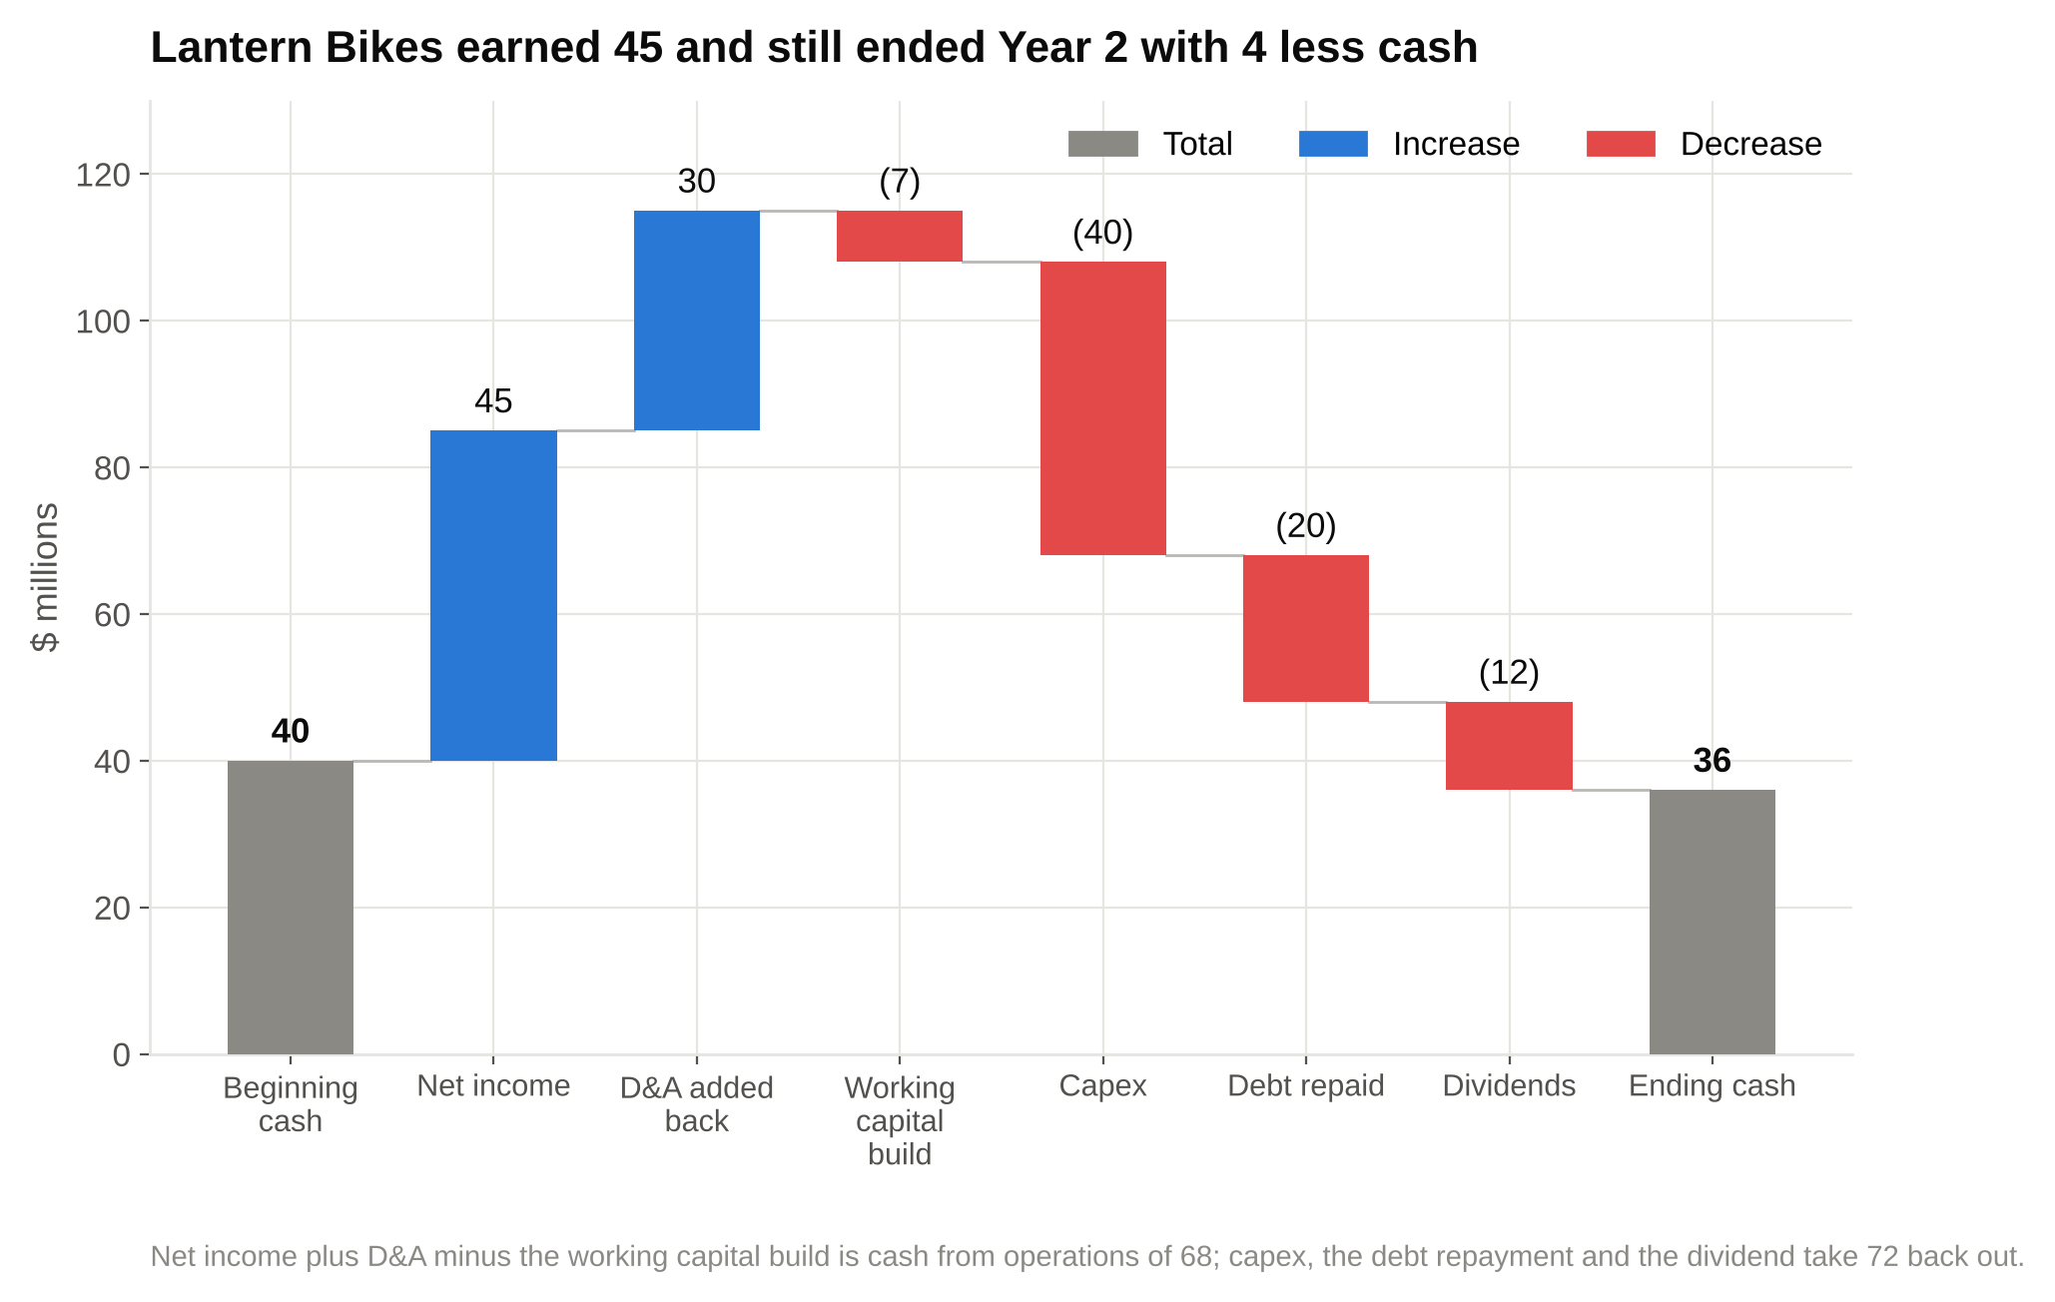
Read it left to right from the 40 Lantern Bikes started with: profit and the D&A add-back lift it to 115, then working capital, capex, the debt repayment and the dividend bring it down to 36.

Now the balance check, which is the part interviewers watch. Assets rose by 21: cash down 4, receivables up 10, inventory up 5, PP&E up 10. Liabilities fell by 12: payables up 6, accrued up 2, debt down 20. Equity rose by 33: net income 45 minus dividends 12. Liabilities plus equity: negative 12 plus 33 is 21. Assets up 21, liabilities and equity up 21. The check is zero because every one of the six links was carried through with the right sign, and a check that isn't zero tells you exactly how big the missing link is. Change any single number in these tables without its partner (say, repay 20 of debt without taking 20 out of cash) and the check breaks by exactly that amount, which is how you'd find the error in a model.

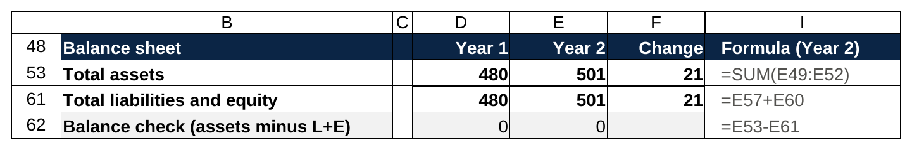
The check is one subtraction, total assets minus total liabilities and equity, and it reads 0 in both years because every link was carried through with its sign.

If you want to build the same thing yourself, this is the exercise: take the Year 1 balance sheet, invent a Year 2 income statement and five or six balance sheet movements, build the cash flow statement from them, and don't stop until the check is zero. Do it three times on a blank page and the $10 of depreciation question becomes trivial, because you'll have watched the full machine turn.

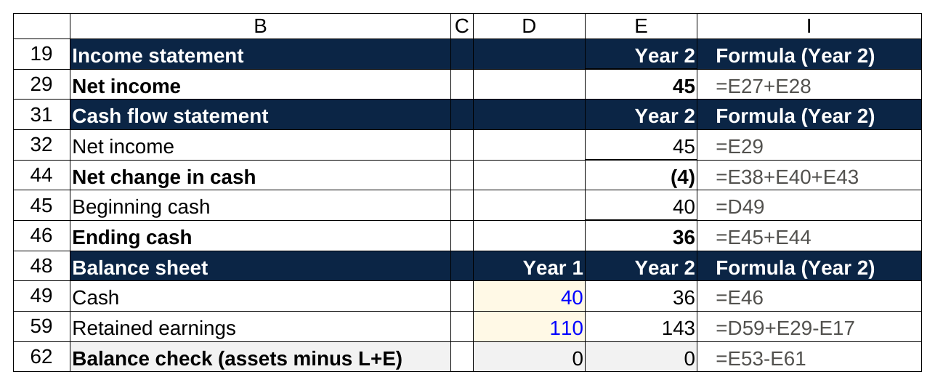
What the links look like as formulas: net income on the cash flow statement is a reference to the income statement, cash on the balance sheet is a reference to ending cash, and retained earnings add net income and subtract the dividend.

7. The follow-ups interviewers use to find out if you memorized it
Once you've walked the depreciation question cleanly, a good interviewer changes the angle. These four come up constantly, and each has a better answer than the one most candidates give.

"If you could only have one statement, which would you pick?" The expected answer is the cash flow statement, and the stronger answer explains the case for each before choosing. The cash flow statement wins for most interviewers because it shows what the company actually generated, after stripping out non-cash charges and timing differences, and cash is what pays the debt and the dividends. The argument for the income statement: it shows whether the business model works, and for a growth company that's losing cash on purpose, the revenue and margin trend tells you more than a cash burn number. The argument for the balance sheet: it's the only one that shows what the company owes and whether it can survive a bad year, and a lender would take it over the other two. Say all three in two sentences each, then pick the cash flow statement and say why. The common extension is "fine, you can have two," and the answer there is the income statement and the balance sheet, because with two consecutive balance sheets and the income statement for the year in between, you can rebuild the cash flow statement yourself: net income from the income statement, every working capital change and the capex and debt moves from the year-over-year balance sheet differences. The cash flow statement is derived; the other two are the source data.

"Can a company have positive net income and negative cash flow?" Yes, and the usual culprit is working capital: the sales are real, but the cash hasn't arrived. Go back to Lantern Bikes. Keep the income statement exactly as it was, with 45 of net income, but make it a fast-growth year: receivables jump by 60 instead of 10 because the company offered big retailers ninety-day terms to win shelf space, and inventory jumps by 50 instead of 5 because it built stock ahead of the season. Cash from operations goes from positive 68 to negative 27, on the same 45 of profit. To cover the gap, Lantern Bikes draws 60 on a revolving credit line (a bank facility it can borrow from and repay as it needs) instead of repaying 20, and skips the dividend.

Fast-growth variant: same net income, receivables up 60 and inventory up 50

Line | Base Year 2 | Fast-growth Year 2
Net income | 45 | 45
Plus: D&A | 30 | 30
Less: increase in accounts receivable | (10) | (60)
Less: increase in inventory | (5) | (50)
Plus: increase in accounts payable | 6 | 6
Plus: increase in accrued expenses | 2 | 2
Cash from operations | 68 | (27)
Capital expenditures | (40) | (40)
Debt repaid (base) or revolver drawn (fast) | (20) | 60
Dividends paid | (12) | 0
Net change in cash | (4) | (7)
Ending cash | 36 | 33
Ending debt | 180 | 260
Balance check | 0 | 0

Same profit, 80 more of debt at year end. That's what "profitable but burning cash" looks like on paper, and it's the pattern behind a lot of growth-company failures: the sales are real, the customers just haven't paid yet, and the bank gets nervous first. The reverse also happens, and the famous case is Amazon. In 2014 it reported a net loss of $241 million and generated $6.8 billion of cash from operations, with $4.9 billion of capital spending on top. Customers paid Amazon at checkout while Amazon paid its suppliers weeks later, so the working capital line ran the opposite direction from Lantern Bikes' fast-growth year, and heavy depreciation on warehouses and servers was added back. Those figures are in Amazon's 2014 10-K. If the interviewer asks for one example, that's the one to have.

"How do the statements differ for a bank, a software company and a retailer?" The lines are the same; what's big and what's small changes completely. For a bank, the balance sheet is the business. Loans are the assets, deposits are the liabilities, and the income statement starts with interest income minus interest expense (net interest income) and then subtracts a provision for loans that won't be repaid before it gets to fees and operating costs. There's no cost of goods sold and no meaningful working capital, so the cash flow statement tells you much less than it does for a manufacturer, and bankers value banks on earnings and book value rather than on EBITDA. For a software company, deferred revenue is the line to watch: customers pay for a year up front, revenue is recognized month by month, and cash from operations runs ahead of net income. Stock-based compensation is a large non-cash add-back, capex is small, and after acquisitions the income statement carries amortization of intangibles that never used cash. For a retailer, inventory is the biggest working capital line and cost of goods sold is the biggest expense, so gross margin is the number everyone watches, the cash flow statement swings hard by quarter around the holidays, and since the 2019 lease accounting change the balance sheet carries store leases as right-of-use assets and lease liabilities, which made retail balance sheets look much more leveraged overnight without changing the stores at all.

"What's above the line and what's below it?" The line is operating income, and the split tells you which costs belong to running the business and which belong to how it's financed and taxed. Above the line: revenue, cost of goods sold, operating expenses, depreciation and amortization. Below the line: interest, other non-operating gains and losses, taxes. The reason bankers care is that enterprise value, the value of the whole business regardless of who funded it, has to be compared with profit measures that are also independent of financing, so EBIT and EBITDA (both above the line) pair with enterprise value, while net income (below the line) pairs with equity value. If a company sold a building at a gain, that gain sits below the line, because it tells you nothing about selling bicycles. The EBITDA explained post covers what gets added back and why, and the walk me through a DCF post shows the same six links turned into unlevered free cash flow, which is EBIT after tax plus D&A minus capex minus the change in working capital, meaning links 2, 3 and 4 pulled straight out of the statements.

8. Where each line lives in a 10-K
The three statements are in Item 8 of every annual report, titled "Financial Statements and Supplementary Data," and the annual report exists because Sections 13 and 15(d) of the Securities Exchange Act of 1934 require companies with publicly traded securities to file one. Every 10-K is free on the SEC's EDGAR database. The habit that makes the statements real is to open one, find each line from the six links, and trace it.

Item 8 opens with the auditor's report and then prints the statements, usually the income statement (often called the statement of operations) first, then comprehensive income, the balance sheet, the equity statement and the cash flow statement, though the order varies by company. The numbers you'll trace:

- Net income: bottom of the income statement, top of the cash flow statement, and in the statement of shareholders' equity as the addition to retained earnings.
- Depreciation and amortization: often not a separate income statement line. Find it in the cash flow statement's operating section, where it has to be shown as an add-back, and in the PP&E note, which lists gross PP&E, accumulated depreciation and the year's charge.
- Capex: the investing section, usually "purchases of property and equipment." The PP&E note shows the roll-forward.
- Working capital changes: the operating section, line by line ("changes in operating assets and liabilities"), and the current assets and current liabilities blocks of the balance sheet. Subtract one year's balance from the other and you should get the cash flow statement line, give or take acquisitions and currency effects.
- Debt: the financing section for issuance and repayment, the balance sheet for the balance, and the debt note for the rates, maturities and covenants, which is also where you'd find the interest rate that produces interest expense.
- Ending cash: the last line of the cash flow statement and the first line of the balance sheet. One check to run: they should match exactly, and if a company holds restricted cash the cash flow statement's total will include it.

The notes that matter most for interviews are the first one (summary of significant accounting policies, which tells you when revenue is recognized and how long assets are depreciated over), the income taxes note (the effective rate, and the deferred tax items that explain why cash taxes differ from the tax line), and the segment note (revenue and operating profit by business, which is where any deal discussion starts). The notes are where the statements explain themselves: revenue timing in the first note, the real tax rate in the tax note, and the business mix in the segment note. Item 7, the management discussion and analysis, is where management defines its own version of free cash flow, and it's worth reading that definition before you quote the number.

Reading one real 10-K end to end, tracing the six links by hand, teaches more about the three financial statements than any question bank. Pick a company that makes physical things, so the capex, inventory and depreciation lines all have real weight, and do it once before your first round.

9. The mistakes that lose the question, and what to say instead
Every mistake below is one I've heard in a mock interview more than once. Most wrong answers to three statement questions come from reciting a memorized walk instead of reasoning through the links, and every mistake on this list is a symptom of that.

Saying depreciation is a cash expense, or saying it has no effect on cash. Both are wrong, in opposite directions. Depreciation uses no cash this year, and it still raises cash by the tax it saves. If you only remember one sentence from this article, make it that one.

Forgetting the tax shield. Net income falls by the expense times one minus the tax rate, not by the full expense. 10 of depreciation at 25 percent is 7.5 of net income, not 10.

Starting on the balance sheet. You don't know cash yet. Start on the income statement, go to the cash flow statement, finish on the balance sheet, check.

Forgetting that cash is on the balance sheet too. Students walk the cash flow statement, get a change in cash, then describe the balance sheet without it. Cash is an asset. It moves. Say it first when you get to the balance sheet.

Forgetting retained earnings. Every change in net income moves retained earnings by the same amount. Skip it and the balance sheet won't balance, and you'll feel it in the room.

Putting working capital on the income statement. Buying inventory, collecting a receivable, paying a supplier: none of these touch the income statement. They're timing moves between cash and another balance sheet line, and the cash flow statement is where they show up.

Not stating the tax rate. "Assuming a 25 percent tax rate" takes two seconds and makes every later number checkable.

Stopping before the check. The last sentence of every walk is "assets are down 7.5, liabilities and equity are down 7.5, so it balances." Say it even if the interviewer looks ready to move on. Stating the tax rate at the start and the balance check at the end are the two habits that make every other mistake visible, and fixable, while you're still in the room.

Say this, don't say that:

"Walk me through $10 of depreciation."
Don't say: "Depreciation is a non-cash expense, so net income goes down by 10 and cash doesn't change."
Say: "Assuming a 25 percent tax rate: pre-tax income falls 10, taxes fall 2.5, net income falls 7.5. On the cash flow statement net income is down 7.5, I add back the 10 of depreciation since it's non-cash, so cash is up 2.5. On the balance sheet cash is up 2.5, PP&E is down 10, assets are down 7.5; retained earnings are down 7.5, so it balances."

"How do the three statements link?"
Don't say: "They're all connected through net income."
Say: "Net income is the top of the cash flow statement and goes into retained earnings. The cash flow statement converts balance sheet changes, D&A, capex, working capital and debt, into cash, and its ending cash is the cash on the balance sheet."

"Which statement would you pick if you could only have one?"
Don't say: "The cash flow statement, because cash is king."
Say: "The cash flow statement, because it shows what the business actually generated after non-cash charges and timing. I'd want the income statement for a growth company and the balance sheet if I were a lender, but for one view of health, cash from operations tells me the most."

"Why does cash go up if depreciation is non-cash?"
Don't say: "Because it's added back on the cash flow statement."
Say: "Because depreciation is tax deductible. Pre-tax income is 10 lower, so the company pays 2.5 less in cash taxes. The add-back on the cash flow statement is how that shows up, but the reason is the tax."

"Inventory goes up by $10. What happens?"
Don't say: "Cost of goods sold goes up by 10, so net income falls."
Say: "Was it paid in cash or on credit? If cash: no income statement effect, cash from operations down 10, inventory up 10 and cash down 10 on the balance sheet. If on credit: still no income statement effect, inventory up 10 and payables up 10, cash unchanged. It only hits the income statement when it's sold."

Build the machine once and the question stops being a question
The students I've watched ace this question built the statements on a blank sheet, broke them on purpose, and fixed them until they could see every link move; none of them memorized the depreciation answer. After that, the interviewer can change the number, the item or the direction, and the answer is the same four steps every time.

So that's the assignment for this week: build it once, break it twice, walk it out loud at a 25 percent tax rate until the two-minute version runs under two minutes. If you're a sophomore mapping the whole technical prep stack, the 2026 investment banking interview guide for sophomores shows where this question sits in it, and the top free resources for IB interview questions post lists the question banks to drill after you've got the links down. The links come first. Everything else in the accounting section is a variation on them.

